project name :- Network File Sharing Server And Client

**Team members :- J . Ameesha**

**B. Supriya**

**M. Haritha**

**High-Level Design**

**Components**

**Server:**

**Responsibilities:**

Listen for incoming client connections.

Receive file requests from clients.

Send requested files to clients.

Handle multiple clients (optional for scalability).

**Client:**

**Responsibilities:**

Connect to the server.

Send file requests to the server.

Receive and save files from the server.

**Communication Protocol**

**Protocol :-**

**Request:** Client sends a request message containing the file name.

**Response:** Server responds by sending the file in chunks.

**Error Handling:** If the file is not found, the server sends an error message.

Workflow

**Client Requests File:**

The client sends a file request message (file name) to the server.

Server Handles Request:

The server receives the request, opens the requested file, and sends it to the client in chunks.

**Client Receives File:**

The client receives the file data in chunks and writes it to a file on disk.

Low-Level Design

Server :-

**Socket Creation:**

Create a socket using socket.socket().

**Bind to Port:**

Bind the socket to a specific port and IP address using socket.bind().

**Listen for Connections:**

Set the socket to listen for incoming connections using socket.listen().

**Accept Connection:**

Accept a client connection using socket.accept().

**Receive File Request:**

Receive the file name request from the client using socket.recv().

**Open and Send File:**

Open the requested file and send it in chunks using file.read() and socket.sendall().

**Error Handling:**

If the file is not found, send an error message to the client.

**Close Connections:**

Close the file and client connection using file.close() and socket.close().

**Client :-**

**1. Socket Creation:**

Create a socket using socket.socket().

**2. Connect to Server:**

Connect the socket to the server using socket.connect().

**3. Send File Request:**

Send the file name request to the server using socket.sendall().

**4. Receive and Save File:**

Receive the file data in chunks and write it to a file on disk using file.write() and socket.recv().

**5. Close Connection:**

Close the socket connection using socket.close().

**FLOWCHART :-**

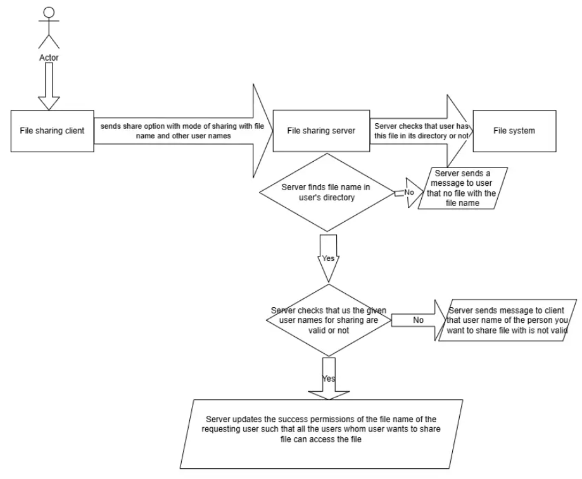

**Sharing a Document Flow Graph :-**

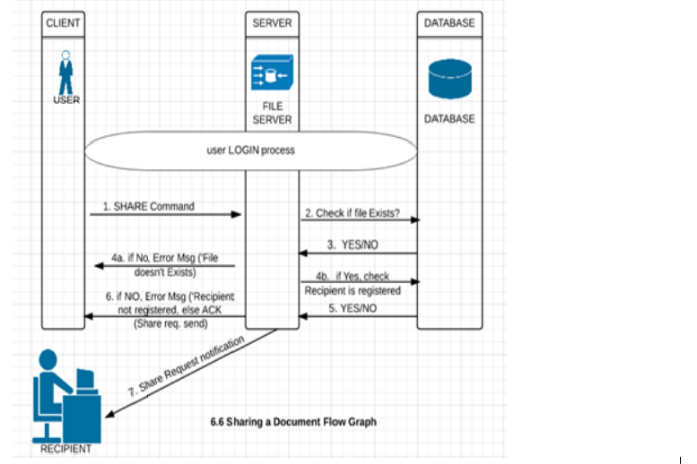

**PSUEDOCODES:**

Pseudocode for server code:

1. Include necessary libraries and header files

- Input/Output

- File handling

- Socket programming

- Threading

- Logger

2. Initialize a Logger instance for logging server activities

3. Define a function `handle_client` with a parameter:

- `client_socket` (socket descriptor **for the connected client)**

Inside `handle_client` function:

a. Define a buffer for data transfer

b. Log the client connection

**c. Receive file information from the client**

**- If receiving fails, log an error message and close the client socket**

**d. Extract filename and file size from the received information**

**e. Open a file for writing received data**

**- If opening the file fails, log an error message and close the client socket**

**f. Receive the file data in chunks**

**- Write each chunk to the file**

**- Update the remaining file size**

**- If receiving fails, log an error message**

**g. Close the file**

**h. Log the successful receipt of the file**

**i. Close the client socket**

**4. Define the `main` function**

**a. Create a socket for server communication**

**- If socket creation fails, log an error and exit**

**b. Set up the server address structure**

**- Set the address family to IPv4**

**- Set the port number**

**- Bind the socket to the server address**

**- If binding fails, log an error and exit**

**c. Start listening for incoming connections**

**- If listening fails, log an error and exit**

**d. Log that the server is listening on the specified port**

**e. Enter an infinite loop to accept incoming connections**

**- Accept a client connection**

**- If accepting fails, log an error and continue to the next connection**

**f. For each accepted client connection:**

**- Create a new thread to handle the client**

**- Detach the thread to handle the client independently**

**g. Close the server socket (unreachable in the current loop)**

**5. End of program**

**Pseudocode for client:**

**1. Include necessary libraries and header files**

**- Input/Output**

**- File handling**

**- Socket programming**

**- Logger**

**2. Initialize a Logger instance for logging client activities**

**3. Define a function `send_file` with parameters:**

**- `filename` (the file to be sent)**

**- `server_ip` (the IP address of the server)**

**- `server_port` (the port on which the server is listening)**

**Inside `send_file` function:**

**a. Create a socket for communication**

**- If socket creation fails, log an error message and exit**

**b. Set up the server address structure**

**- Set the address family to IPv4**

**- Set the port number**

**- Convert the IP address from string to network format**

**- If address conversion fails, log an error message and close the socket**

**c. Connect to the server using the socket**

**- If connection fails, log an error message and close the socket**

**d. Open the file to be sent**

**- If file opening fails, log an error message and close the socket**

**e. Get the file size**

**- Prepare a file info string containing filename and file size**

**- Send the file info string to the server**

**f. Send the file content in chunks**

**- Read the file content into a buffer**

**- Send the buffer contents to the server**

**- Continue until the entire file is sent**

**g. Close the file**

**h. Log a success message**

**i. Close the socket**

**4. Define the `main` function**

**a. Prompt the user for the filename to send**

**b. Call `send_file**` function **with the user-provided filename, server IP, and port**

**5. End of program**

**LOGGER CODES:**

CLASS **CODE FOR LOGGER.H :-**

**#ifndef LOGGER_H**

**#define LOGGER_H**

**#include <iostream>**

**#include <fstream>**

**#include <string>**

**#include <mutex>**

**class Logger {**

**private:**

**std::ofstream log_file;**

**std::mutex log_mutex;**

**public:**

**Logger(const std::string &file_name) {**

**log_file.open(file_name, std::ios::app);**

**if (!log_file.is_open()) {**

**std::cerr << "Failed to open log file: " << file_name << std::endl;**

**}**

**}**

**~Logger() {**

**if (log_file.is_open()) {**

**log_file.close();**

**}**

**}**

**void log(const std::string &message) {**

**std::lock_guard<std::mutex> guard(log_mutex);**

**std::cout << message << std::endl;**

**if (log_file.is_open()) {**

**log_file << message << std::endl;**

**}**

**}**

**};**

**#endif**

**SERVER CODE WITH LOGGER.H :-**

**#include <iostream>**

**#include <fstream>**

**#include <cstring>**

**#include <sys/socket.h>**

**#include <netinet/in.h>**

**#include <unistd.h>**

**#include <thread>**

**#include "logger.h" // Include the logger**

**Logger logger("server_log.txt"); // Create a logger instance for the server**

**void handle_client(int client_socket) {**

**char buffer[1024];**

**// Log client connection**

**logger.log("Client connected");**

**// Receive file info**

**ssize_t bytes_received = recv(client_socket, buffer, sizeof(buffer) - 1, 0);**

**if (bytes_received <= 0) {**

**logger.log("Error receiving file info");**

**close(client_socket);**

**return;**

**}**

**buffer[bytes_received] = '\0';**

**std::string file_info(buffer);**

**size_t comma_pos = file_info.find(',');**

**std::string filename = file_info.substr(0, comma_pos);**

**size_t filesize = std::stoul(file_info.substr(comma_pos + 1));**

**// Open file to write received data**

**std::ofstream output_file(filename, std::ios::binary);**

**if (!output_file) {**

**logger.log("Error opening file");**

**close(client_socket);**

**return;**

**}**

**// Receive file data**

**while (filesize > 0) {**

**ssize_t bytes_received = recv(client_socket, buffer, sizeof(buffer), 0);**

**if (bytes_received <= 0) {**

**logger.log("Error receiving file data");**

**break;**

**}**

**output_file.write(buffer, bytes_received);**

**filesize -= bytes_received;**

**}**

**output_file.close();**

**logger.log("Received file: " + filename);**

**close(client_socket);**

**}**

**int main() {**

**int server_fd = socket(AF_INET, SOCK_STREAM, 0);**

**if (server_fd < 0) {**

**logger.log("Socket creation error");**

**return 1;**

**}**

**sockaddr_in server_addr {};**

**server_addr.sin_family = AF_INET;**

**server_addr.sin_addr.s_addr = INADDR_ANY;**

**server_addr.sin_port = htons(65432);**

**if (bind(server_fd, (struct sockaddr*)&server_addr, sizeof(server_addr)) < 0) {**

**logger.log("Bind failed");**

**close(server_fd);**

**return 1;**

**}**

**if (listen(server_fd, 5) < 0) {**

**logger.log("Listen failed");**

**close(server_fd);**

**return 1;**

**}**

**logger.log("Server listening on port 65432");**

**while (true) {**

**sockaddr_in client_addr {};**

**socklen_t client_addr_len = sizeof(client_addr);**

**int client_socket = accept(server_fd, (struct sockaddr*)&client_addr, &client_addr_len);**

**if (client_socket < 0) {**

**logger.log("Accept failed");**

**continue;**

**}**

**std::thread(handle_client, client_socket).detach();**

**}**

**close(server_fd);**

**return 0;**

**}**

**OUTPUT FOR SERVER CODE WITH LOGGER.H :-**

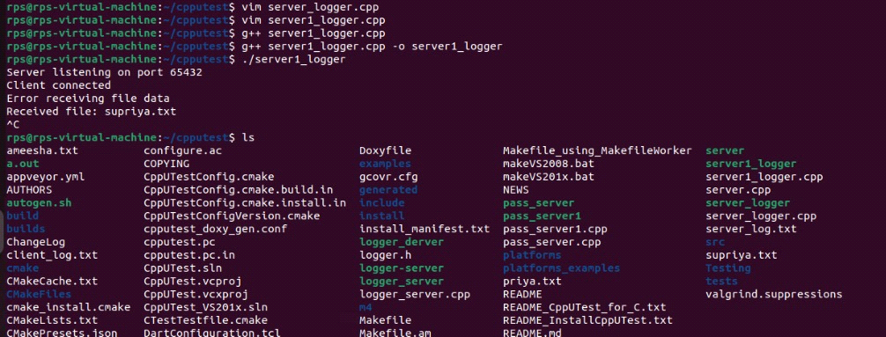

**CLIENT CODE WITH LOGGER.H :-**

**#include <iostream>**

**#include <fstream>**

**#include <cstring>**

**#include <sys/socket.h>**

**#include <netinet/in.h>**

**#include <unistd.h>**

**#include "logger.h" // Include the logger**

**Logger logger("client_log.txt"); // Create a logger instance for the client**

**void send_file(const std::string& filename, const std::string& server_ip, uint16_t server_port) {**

**int client_socket = socket(AF_INET, SOCK_STREAM, 0);**

**if (client_socket < 0) {**

**logger.log("Socket creation error");**

**return;**

**}**

**sockaddr_in server_addr {};**

**server_addr.sin_family = AF_INET;**

**server_addr.sin_port = htons(server_port);**

**if (inet_pton(AF_INET, server_ip.c_str(), &server_addr.sin_addr) <= 0) {**

**logger.log("Invalid address/ Address not supported");**

**close(client_socket);**

**return;**

**}**

**if (connect(client_socket, (struct sockaddr*)&server_addr, sizeof(server_addr)) < 0) {**

**logger.log("Connection failed");**

**close(client_socket);**

**return;**

**}**

**std::ifstream input_file(filename, std::ios::binary | std::ios::ate);**

**if (!input_file) {**

**logger.log("Error opening file");**

**close(client_socket);**

**return;**

**}**

**std::streamsize filesize = input_file.tellg();**

**input_file.seekg(0, std::ios::beg);**

**std::string file_info = filename + "," + std::to_string(filesize);**

**send(client_socket, file_info.c_str(), file_info.size(), 0);**

**char buffer[1024];**

**while (input_file.read(buffer, sizeof(buffer)) || input_file.gcount() > 0) {**

**send(client_socket, buffer, input_file.gcount(), 0);**

**}**

**input_file.close();**

**logger.log("File sent successfully");**

**close(client_socket);**

**}**

**int main() {**

**std::string filename;**

**std::cout << "Enter the filename to send: ";**

**std::cin >> filename;**

**send_file(filename, "127.0.0.1", 65432);**

**return 0;**

**}**

**OUTPUT FOR CLIENT WITH LOGGER.H :-**

